COLLEGE OF COMPUTER STUDIES DEPARTMENT
THESIS PROJECT
TITLE PROPOSAL
(CS0025 – Software Engineering 1)

Group Name: Statisfied | Program:  Bachelor of Science in Computer Science  with specialization in Data Science
Member’s Name:  1. Dawn Andrei Pamesa (Project Manager)  2. Rogelio Porras (Member 1)  3. John Ashley Alba (Member 2)  4. Ralph Blanco (Member 3) | Term:  [✓] 1st [ ] 2nd [ ] 3rd | Academic Year:  2026 - 2027
Proposed Project Title 3:
AquaRoute: A Demand Prediction Model and Route Optimization System for Dr. Pi Oxygenated Water

1.0 Area of Investigation:
The proposed study focuses on predictive analytics, delivery demand forecasting, geospatial analysis, and route planning for small water delivery businesses. It aims to develop a decision-support system for Dr. Pi Oxygenated Water that can predict future delivery demand and recommend suitable delivery routes using historical orders and operational records.
Water delivery services require regular trips from the business to customers' homes and businesses. The number of orders, delivery schedules, and customer locations can change each day. Without proper planning, businesses may experience longer travel distances, uneven workloads among delivery personnel, and difficulties managing orders during busy periods. These are possible operational challenges that the researchers will verify through an interview with Dr. Pi. They have not yet confirmed problems within the business.
The study will examine how machine learning can predict daily delivery orders and the number of water gallons needed. It will also assess whether a vehicle routing method that considers carrying capacity can improve delivery planning compared with the business's current process. Previous studies have examined the use of route planning methods for last-mile deliveries and the connection between demand forecasting and routing decisions (Jazemi et al., 2023; Fleckenstein et al., 2023).
The proposed system will include the following modules:
1. Data Collection and Preprocessing: Collects, cleans, and organizes historical delivery orders, delivery dates and times, gallon quantities, customer service areas, and vehicle information.
2. Feature Engineering: Prepares variables such as daily order counts, previous delivery demand, rolling averages, days of the week, holidays, and service locations for forecasting.
3. Delivery Demand Forecasting: Uses XGBoost to predict short-term delivery demand, including the expected number of orders and water gallons needed.
4. Route Optimization: Recommends delivery routes, delivery sequences, and rider assignments based on customer locations and the carrying capacity of available delivery vehicles.
5. Dashboard and Reporting: Displays forecast demand, route recommendations, estimated distance, workload, and evaluation results.
Algorithm/Technique Justification
Identified Problem | Potentially inefficient delivery sequences, uncertain daily delivery demand, and uneven rider workloads. These concerns will be validated with Dr. Pi before being treated as confirmed operational problems
Computational Task | Two tasks: (1) supervised regression/time-series forecasting of daily order counts and gallon quantities; and (2) capacitated vehicle routing using confirmed delivery locations, quantities, and available riders/vehicles.
Proposed Algorithm/Technique | XGBoost regression for demand forecasting; Capacitated Vehicle Routing Problem (CVRP) solved using a heuristic/metaheuristic or constraint solver for delivery route planning. A single-rider operation will use a single-vehicle route variant.
Reason for Selection | XGBoost can use nonlinear relationships among lagged orders, calendar variables, and service areas. CVRP explicitly models the number of stops and vehicle carrying capacities, making the routing component operationally meaningful. The forecasting model is evaluated independently from the route solver.
Required Input/Data | Completed order records (date/time, gallons, area), scheduled delivery locations, delivery quantities, starting point, rider/vehicle availability, carrying capacities, and travel distance/time estimates. Actual routes and travel times are desirable for comparison.
Expected Output | Next-day or next-week expected delivery orders/gallons; route sequence and rider assignment for confirmed orders; estimated travel distance and time; workload summaries; and model performance results.
Alternative Algorithms | Forecasting: seasonal naive and Random Forest. Routing: nearest-neighbor route construction and the current/manual route as baselines. Additional routing heuristics may be tested if feasible.
Evaluation Method | Chronological split by date, about 70% for training, 15% for validation and 15% for the final test, or rolling-origin validation, for forecasts, measured using MAE, RMSE, and WAPE. Route performance assessed through total distance, estimated travel time, capacity violations, and solver time; compare the same order sets against existing/manual routes or a defined baseline.

2.0 Background and Rationale of the Project/System:
Proper delivery planning is important for water delivery businesses since customers expect their drinking water to arrive on time. Managing deliveries becomes more challenging when orders come in at different times, customers live in different areas, and delivery vehicles can only carry a limited number of gallons. Reviews of last-mile delivery describe its logistics, its challenges and its research directions (Liu & Hassini, 2024; Masorgo et al., 2024). The study will first examine how Dr. Pi currently handles customer orders, assigns delivery riders, and plans delivery routes.
In last-mile delivery operations, route planning affects travel time, transportation expenses, and customer service. Jazemi et al. (2023) reviewed different vehicle routing methods used in urban delivery operations. Adamo et al. (2024) studied routing methods that account for changes in travel time. These studies provide a basis for applying and testing route planning methods in a small water delivery business. Studies of the capacitated vehicle routing problem have compared construction heuristics such as the nearest neighbor and sweep methods with improvement metaheuristics (Ekayanti et al., 2024; Muriyatmoko et al., 2024), tested a simulation-based metaheuristic under capacity limits and demand uncertainty in waste collection (Jasmine et al., 2025), and examined learning-based approaches to routing (Fitzpatrick et al., 2024; Zhou et al., 2025).
Historical order records can help businesses understand and predict delivery demand. Customer orders may change depending on weekdays, weekends, holidays, and service areas. A forecasting model can estimate the number of deliveries expected for the following day. Gradient boosting methods such as XGBoost have been applied to sales and demand forecasting (Dankorpho, 2024; Elorza et al., 2025; Nguyen et al., 2025), and studies of retail forecasting, including the M5 competition, show how demand models are compared and evaluated (Fildes et al., 2022; Ma & Fildes, 2022; Makridakis et al., 2022; Mitra et al., 2022). These predictions can help the business prepare its workforce and plan daily operations. However, final delivery routes must still be based on confirmed customer orders and actual delivery locations rather than forecasts alone.
The proposed AquaRoute system will combine two main functions: predicting future delivery demand using historical orders and planning delivery routes based on confirmed orders. The system aims to help Dr. Pi manage its delivery operations through data-based forecasts and route recommendations. It will serve as a planning and decision-support tool rather than an automated dispatch system. Related research by Özarık et al. (2024) has examined the use of data analysis and machine learning to improve last-mile delivery routes. Other work has combined demand management with tour planning for same-day delivery (Klein & Steinhardt, 2023) and used data-driven methods for routing in online retailing (Wei et al., 2024).

3.0 Statement of Objectives:
General objective. To develop and evaluate AquaRoute, a decision-support system for Dr. Pi Oxygenated Water that predicts delivery demand with machine learning and recommends delivery routes, using historical delivery records and operational constraints available from the client.
Specific objectives. The specific objectives are as follows:
1. To collect, clean, and consolidate historical delivery transactions, delivery quantities, service locations, and vehicle/rider information provided by Dr. Pi.
2. To identify daily and area-level delivery demand patterns using descriptive analytics and calendar-based features.
3. To develop an XGBoost model for predicting daily delivery order counts and gallon quantities for a defined short-term forecast horizon.
4. To compare XGBoost with seasonal naive and Random Forest baselines using chronological evaluation (about 70% / 15% / 15% by date for training, validation and test) and MAE, RMSE, and WAPE.
5. To develop a capacity-aware routing module that recommends feasible delivery sequences and rider assignments for confirmed orders.
6. To evaluate recommended routes against manual or nearest-neighbor routes using total distance, estimated travel time, capacity feasibility, and computation time.
7. To create and assess a web dashboard that presents forecasts, optimized routes, workload summaries, and model evaluation results among intended users.

4.0 Scope and Limitations of the Study:
Scope. The study will focus on the local delivery operations of Dr. Pi Oxygenated Water and on a selected geographic service area approved by the client. Demand forecasts will be produced at a daily level, with a proposed one- to seven-day horizon. The route optimizer will use actual confirmed orders, stop locations, gallon quantities, and the carrying capacities of available vehicles.
• Historical delivery data preparation and descriptive analysis.
• Daily order-count and gallon-demand forecasts.
• Capacity-aware delivery route recommendations for one or more riders, depending on actual operations.
• Route visualization and performance reporting through a browser-based dashboard.
• Evaluation of forecast quality and route efficiency against appropriate baselines.
Delimitations. The study will exclude the following areas:
• The study does not include water filtration quality prediction, equipment maintenance prediction, or water production automation.
• It does not process online payments or implement a complete point-of-sale system.
• It does not guarantee live traffic-aware routing; static travel-time or distance estimates may be used when traffic data are unavailable.
• It does not automatically contact customers or dispatch riders without staff approval.
Limitations. The accuracy of demand forecasts will depend on the quality, completeness, and consistency of Dr. Pi's historical order records. If the available data is limited or incomplete, the study may need to use a simpler forecasting model and focus on shorter prediction periods. The accuracy of route recommendations will depend on road network data and the availability of previous delivery route records. Unexpected events such as road closures, heavy traffic, sudden orders, unavailable customers, and rider schedules can affect actual delivery performance.
Customer addresses and locations will be treated as sensitive information. The study will collect only the necessary data, assign anonymous customer IDs, limit access to authorized personnel, and exclude identifiable customer details from research reports. The system will provide recommendations for delivery planning, but staff members will remain responsible for reviewing and approving final decisions.

5.0 Target Beneficiaries:
The primary beneficiaries of this study are:
Dr. Pi Oxygenated Water Management. Management may use delivery demand estimates and route comparisons to plan workload, staffing, and operating schedules.
Delivery Riders and Personnel. Riders may benefit from clearer delivery sequences and capacity-aware assignments that reduce unnecessary travel, subject to evaluation.
Customers. Customers may benefit from more consistent service and better delivery planning if the recommendations are adopted and prove effective.
Student Researchers and Future Developers. The project may serve as a case study on combining demand forecasting and routing optimization in a small local delivery operation.

6.0 SDG Category Number:
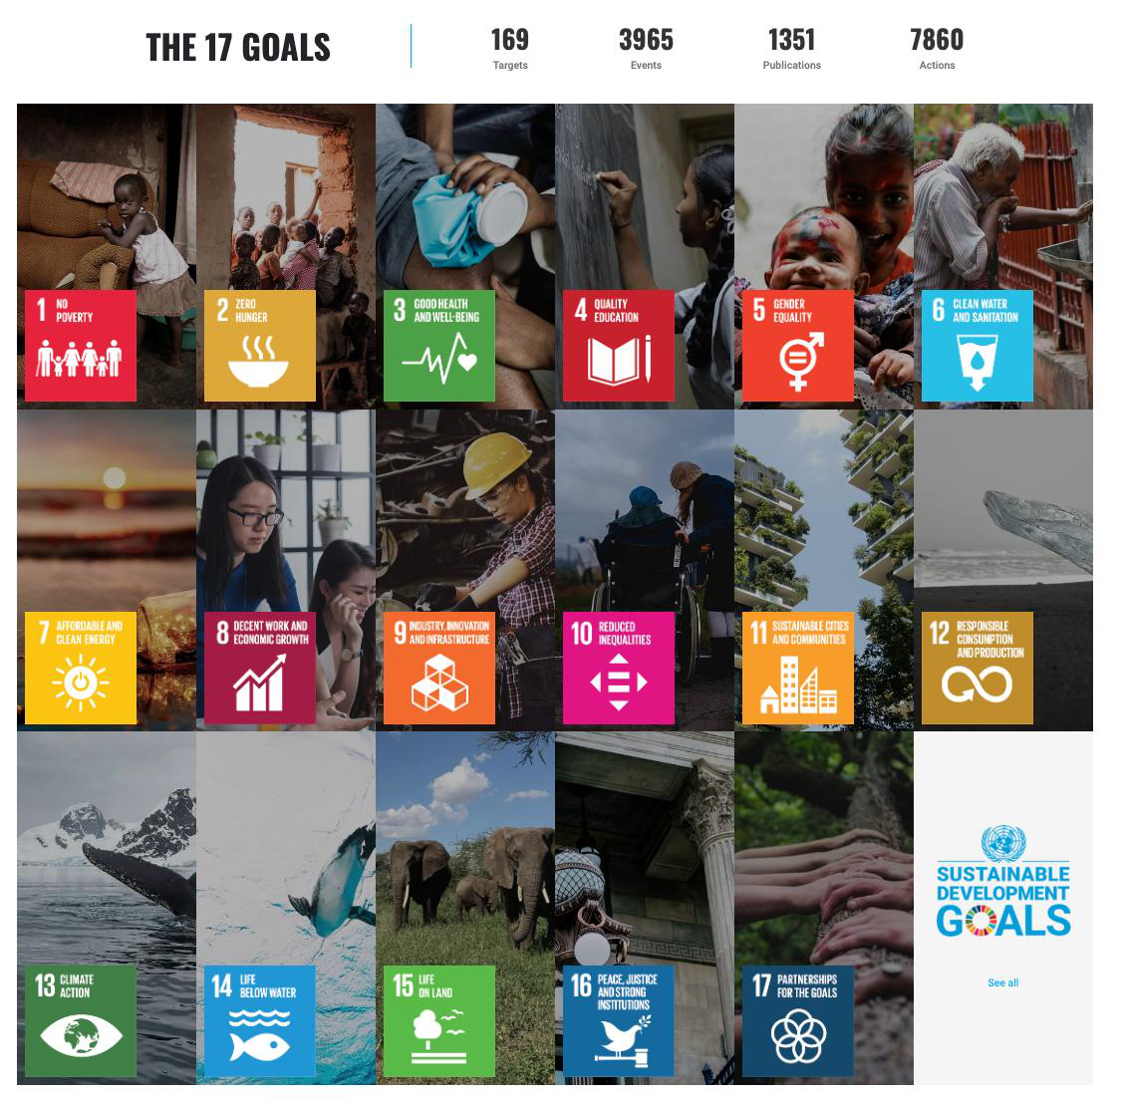
SDG Number: 9 and 11
SDG Title: Industry, Innovation, and Infrastructure; Sustainable Cities and Communities
Justification: SDG 9. AquaRoute supports the use of data-driven methods in small-business logistics by combining machine learning with route optimization for operational decision support. SDG 11. More efficient local delivery routes could reduce unnecessary travel distance and support more organized neighborhood delivery operations. Any environmental or service improvement would need to be demonstrated through the study's evaluation.

7.0 References:
Adamo, T., Gendreau, M., Ghiani, G., & Guerriero, E. (2024). A review of recent advances in time-dependent vehicle routing. European Journal of Operational Research, 319(1), 1–15. https://doi.org/10.1016/j.ejor.2024.06.016
Dankorpho, P. (2024). Sales forecasting for retail business using XGBoost algorithm. Journal of Computer Science and Technology Studies, 6(2), 136–141. https://doi.org/10.32996/jcsts.2024.6.2.15
Ekayanti, E., Sugianto, & Efendi, I. B. (2024). Capacitated vehicle routing problem (CVRP) with sweep and nearest neighbor algorithm. Sinergi International Journal of Logistics, 2(1), 17–29. https://doi.org/10.61194/sijl.v2i1.187
Elorza, M., Castellano, E., & Segura, S. (2025). Prediction of customer demand for perishable products in retail inventory management, using the hybrid Prophet-XGBoost model during the post-COVID-19 period. Applied Economics Letters, 32(17), 2453–2459. https://doi.org/10.1080/13504851.2024.2333995
Fildes, R., Ma, S., & Kolassa, S. (2022). Retail forecasting: Research and practice. International Journal of Forecasting, 38(4), 1283–1318. https://doi.org/10.1016/j.ijforecast.2019.06.004
Fitzpatrick, J., Ajwani, D., & Carroll, P. (2024). A scalable learning approach for the capacitated vehicle routing problem. Computers & Operations Research, 171, Article 106787. https://doi.org/10.1016/j.cor.2024.106787
Fleckenstein, D., Klein, R., & Steinhardt, C. (2023). Recent advances in integrating demand management and vehicle routing: A methodological review. European Journal of Operational Research, 306(2), 499–518. https://doi.org/10.1016/j.ejor.2022.04.032
Jasmine, T. L., Putro, H. P. H., Prilandita, N., & Yudoko, G. (2025). A simulation based metaheuristics for capacitated vehicle routing problem. Automotive Experiences, 8(1), 159–176. https://doi.org/10.31603/ae.13242
Jazemi, R., Alidadiani, E., Ahn, K., & Jang, J. (2023). A review of literature on vehicle routing problems of last-mile delivery in urban areas. Applied Sciences, 13(24), Article 13015. https://doi.org/10.3390/app132413015
Klein, V., & Steinhardt, C. (2023). Dynamic demand management and online tour planning for same-day delivery. European Journal of Operational Research, 307(2), 860–886. https://doi.org/10.1016/j.ejor.2022.09.011
Liu, S., & Hassini, E. (2024). Freight last mile delivery: A literature review. Transportation Planning and Technology, 47(3), 323–369. https://doi.org/10.1080/03081060.2023.2268601
Ma, S., & Fildes, R. (2022). The performance of the global bottom-up approach in the M5 accuracy competition: A robustness check. International Journal of Forecasting, 38(4), 1492–1499. https://doi.org/10.1016/j.ijforecast.2021.09.002
Makridakis, S., Spiliotis, E., & Assimakopoulos, V. (2022). M5 accuracy competition: Results, findings, and conclusions. International Journal of Forecasting, 38(4), 1346–1364. https://doi.org/10.1016/j.ijforecast.2021.11.013
Masorgo, N., Dobrzykowski, D. D., & Fugate, B. S. (2024). Last-mile delivery: A process view, framework, and research agenda. Journal of Business Logistics, 45(4), Article e12397. https://doi.org/10.1111/jbl.12397
Mitra, A., Jain, A., Kishore, A., & Kumar, P. (2022). A comparative study of demand forecasting models for a multi-channel retail company: A novel hybrid machine learning approach. SN Operations Research Forum, 3, Article 58. https://doi.org/10.1007/s43069-022-00166-4
Muriyatmoko, D., Djunaidy, A., & Muklason, A. (2024). Heuristics and metaheuristics for solving capacitated vehicle routing problem: An algorithm comparison. Procedia Computer Science, 234, 494–501. https://doi.org/10.1016/j.procs.2024.03.032
Nguyen, N. P. T., Dang, T. T., & Le, D. D. (2025). Inventory demand forecasting using XGBoost and LightGBM algorithms: A case study of Grupo Bimbo. In Management science and industrial engineering: Proceedings of the 7th International Conference (MSIE 2025) (pp. 46–57). https://doi.org/10.3233/ATDE250516
Özarık, S. S., da Costa, P., & Florio, A. M. (2024). Machine learning for data-driven last-mile delivery optimization. Transportation Science, 58(1), 27–44. https://doi.org/10.1287/trsc.2022.0029
Wei, J., Xu, X., & Yang, B. (2024). Data-driven vehicle rental and routing optimization: An application in online retailing. Computers & Industrial Engineering, 197, Article 110588. https://doi.org/10.1016/j.cie.2024.110588
Zhou, F., Lischka, A., Kulcsár, B., Wu, J., Chehreghani, M. H., & Laporte, G. (2025). Learning for routing: A guided review of recent developments and future directions. Transportation Research Part E: Logistics and Transportation Review, 202, Article 104278. https://doi.org/10.1016/j.tre.2025.104278

Approved by:

______________________
Panel Member 1 / Date

______________________
Panel Member 2 / Date

Noted by:

___________________________
Thesis 1 Course Adviser / Date

1. AI Interaction Log (if applicable)
If your group used any Generative AI tool while completing the assessment, document how the tool was used. The log should demonstrate that AI supported the group’s work rather than replacing the group’s research, analysis, and decision-making.
Group Member | AI Tool Used | Prompt / Purpose | AI Output Used For | How the Output Was Verified or Modified
Dawn Andrei Pamesa | Claude (Claude Code) | Checked each reference against Crossref (DOI, authors, year, journal, volume and pages); corrected one author name and the alphabetical order of the reference list; put the proposal into the official layout. It did not write the proposal text. | Reference corrections and formatting. | Every DOI was looked up on Crossref and compared with the details cited in the proposal.
Rogelio Porras | ChatGPT and Codex | Helped search for sources, and helped brainstorm and proofread his writing. | A list of possible sources, brainstorming ideas, and proofreading. | He read the sources himself before using them.
John Ashley Alba | ChatGPT | Helped gather sources and ideas, and helped check his work. | Suggestions of sources and ideas, and checking his work. | He read the sources himself and cross-checked them with other sites.
Ralph Blanco | Custom GPT (thesis manuscript checker) | Used to check his draft. | Feedback on the draft. | He cross-checked the suggestions before applying them.

2. AI Usage Declaration
We declare that any use of Generative AI in completing this Technical Assessment has been properly disclosed in the AI Interaction Log. We understand that AI is used only as an assistive tool and that our group remains responsible for verifying the accuracy, relevance, credibility, and originality of the submitted work.
We confirm that the final title proposal, objectives, scope, algorithm justification, and research outputs reflect our group’s understanding and decisions. All literature, studies, and other external sources used have been properly cited and verified.
Group Name: Statisfied
Date: October 31, 2026
Group Member | Signature
Dawn Andrei Pamesa | 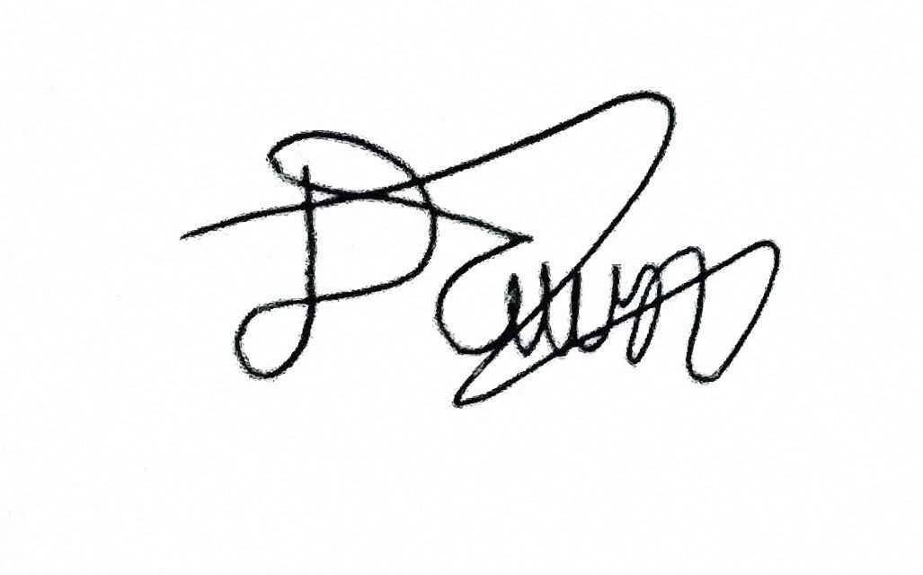
Rogelio Porras | 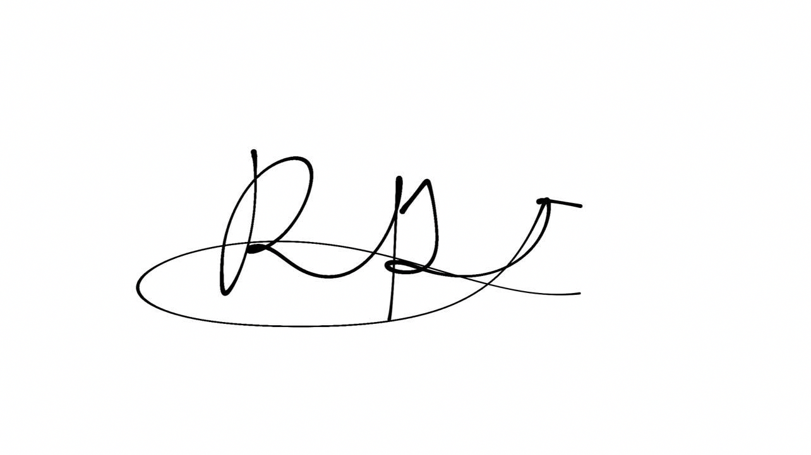
John Ashley Alba | 
Ralph Blanco | 

3. Team Contribution Matrix
The total contribution percentage must equal 100%.
Group Member | Assigned Task/Responsibility | Specific Contribution/Output | Contribution (%)
Dawn Andrei Pamesa | Project Manager; helped Ralph with the idea. | Ideas for the proposal; reference check and formatting, done with Claude. | 30%
Rogelio Porras | Review of related literature and systems (RRL and RRS). | Sources and write-up for the RRL and RRS. | 23%
John Ashley Alba | Review of related literature and systems (RRL and RRS). | Sources and write-up for the RRL and RRS. | 23%
Ralph Blanco | Main author of the proposal. | Most of the proposal for Dr. Pi Oxygenated Water. | 24%
 |  | Total | 100%

